CSW art exhibition: Details of the artworks
These advocacy artworks resulted from an Art Fellowship Programme offered by the Centre of Excellence for Gender, Sexual and Reproductive Health and Rights (CGSRHR) at the school to 11 young artists to showcase the struggle of structurally silenced women in Bangladesh. The school collaborates with CREA India to implement the ‘Our Voices, Our Futures’ project, from where the fellowship was offered. ‘Oroddho Foundation’ was the implementation partner for this art fellowship programme.
- Artwork:

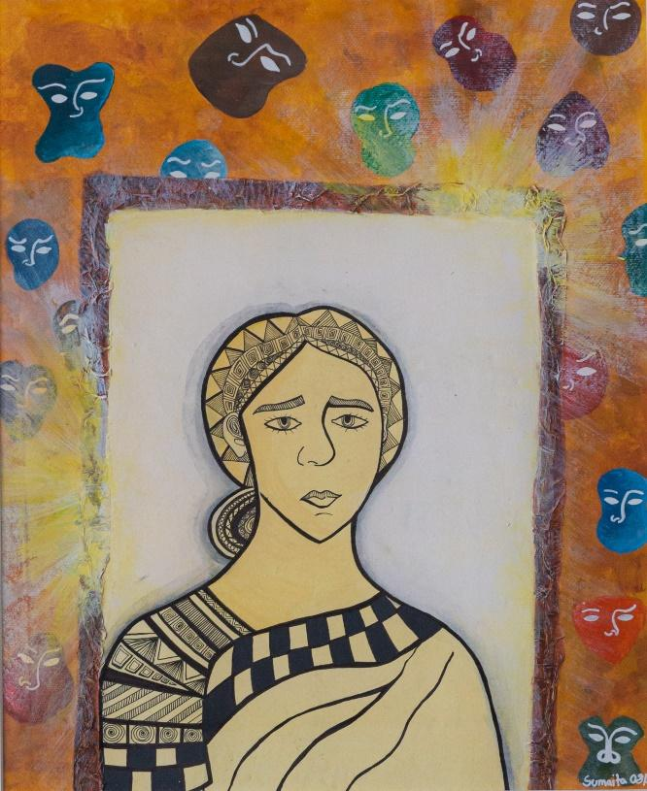 | 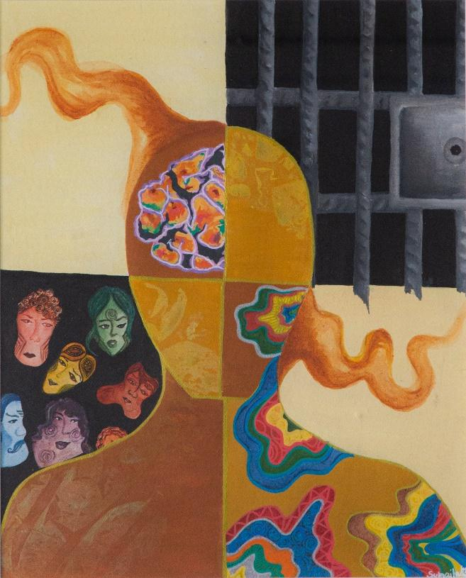
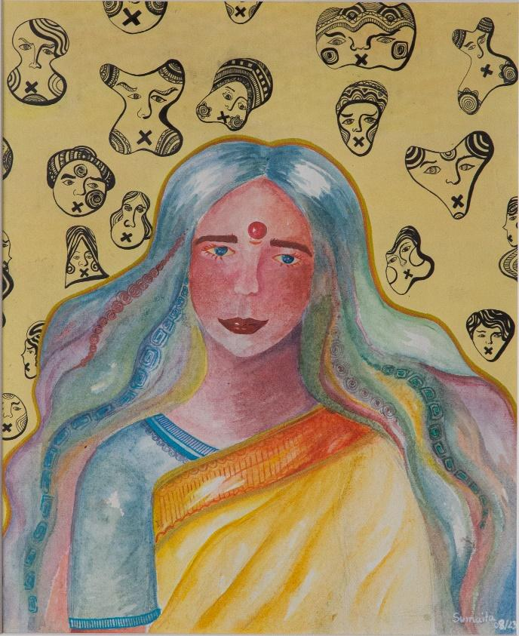 | 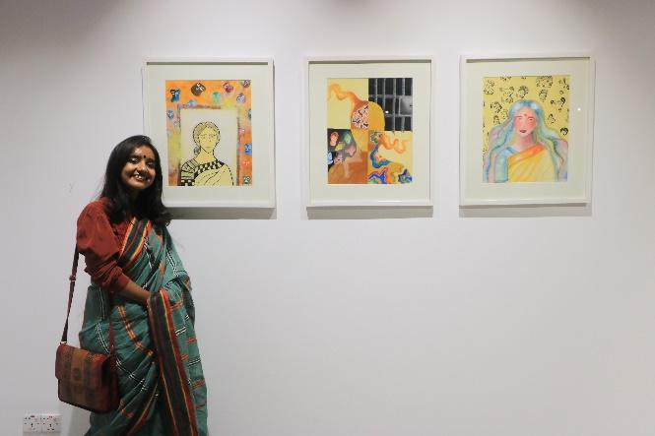

Description of the artwork:
Sumaita Afrid Nuha’s paintings represent women who have endured toxic marriages despite facing abuse and have confronted societal taboos when attempting to break free.
Artist’s short bio:
Sumaita Afrid Nuha is a self-taught artist who loves to express herself through various art forms. She is a 19-year-old young student who is currently enrolled in 11th grade at Birshreshtha Noor Mohammad Public College, Dhaka.

- Artwork:

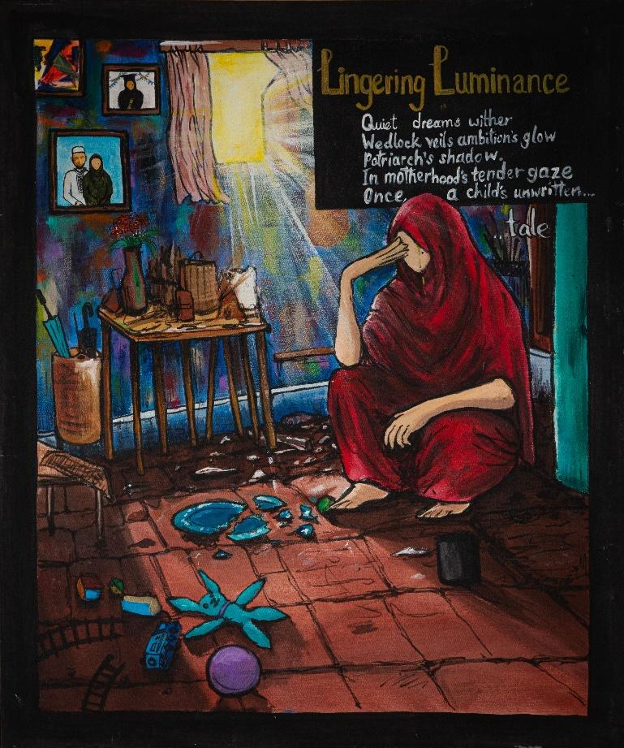 | 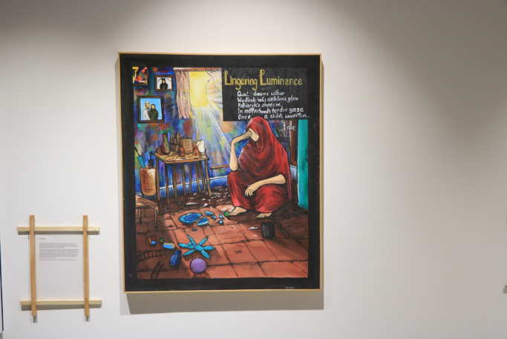

Description of the artwork:
Hijol (pseudonym) believes that darkness is simply the absence of light, and the light within us never truly fades. Through the artwork, he sheds light on the narratives of mothers who have been silenced and had to abandon their dreams due to the patriarchal nature of families in Bangladesh.
Artist’s short bio:
‘Hijol’ (Pseudonym) is a Dhaka-based poet and writer. He uses vivid imagery and elements of the mundane to establish his narrative. His works primarily revolve around radicalized emotions, conflicts, human nature, and societal constructs. He is 19 years old and currently completing his high-school education at Saint Joseph Higher Secondary School as an HSC candidate.

- Artwork:
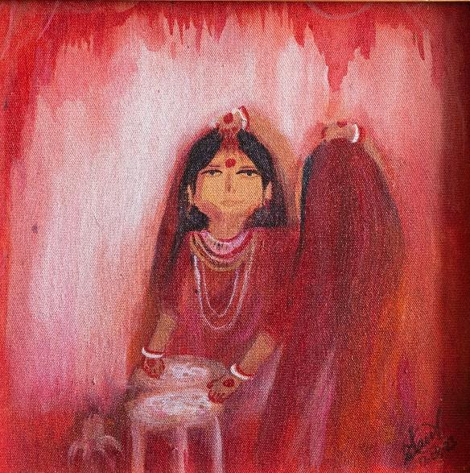 | 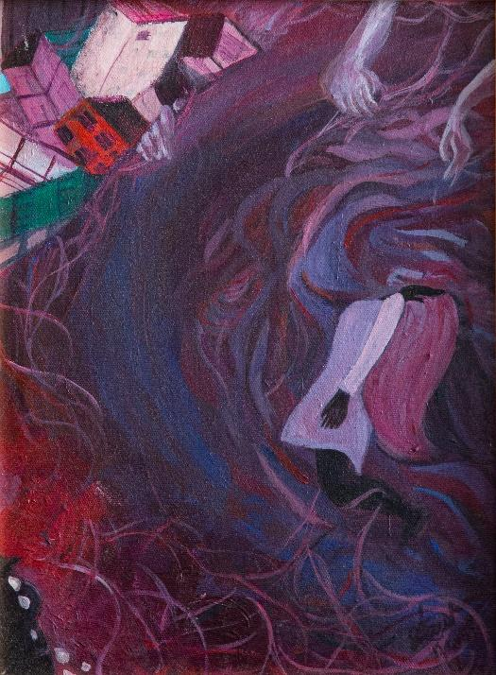
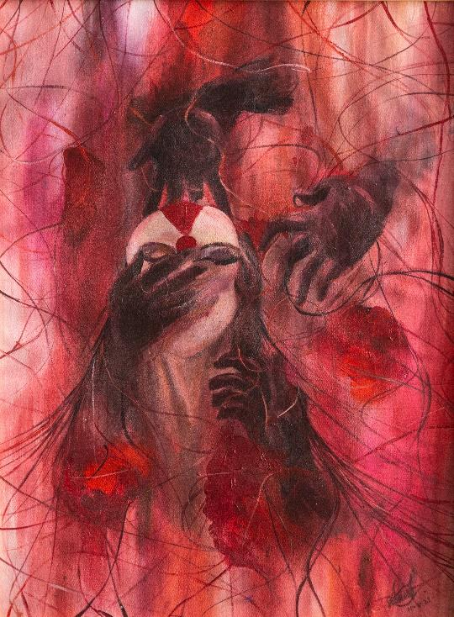 | 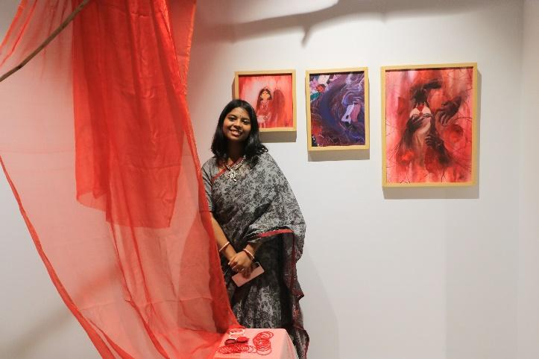

Description of the artwork:
This series of paintings portrays the stories and struggles of Hindu minority women in Bangladesh.

Artist’s short bio:
Sreyonti Paul is an 18-year-old student in grade 10 who wants to raise awareness and challenge prevailing societal norms through her artwork.

Additional (if needed)
These advocacy materials resulted from a University Poster Competition offered by the Centre of Excellence for Gender, Sexual and Reproductive Health and Rights (CGSRHR) at the school to university students so they can become the voice for structurally silenced women in Bangladesh. The school collaborates with CREA India to implement the ‘Our Voices, Our Futures’ project, from where the poster competition was offered.
- Artwork:
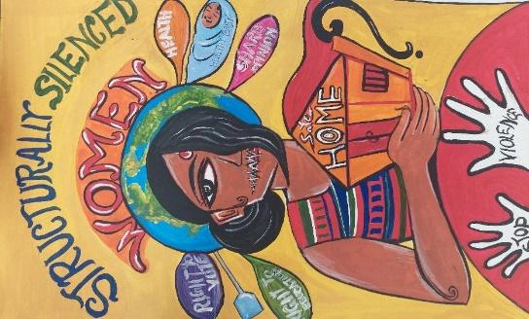 | 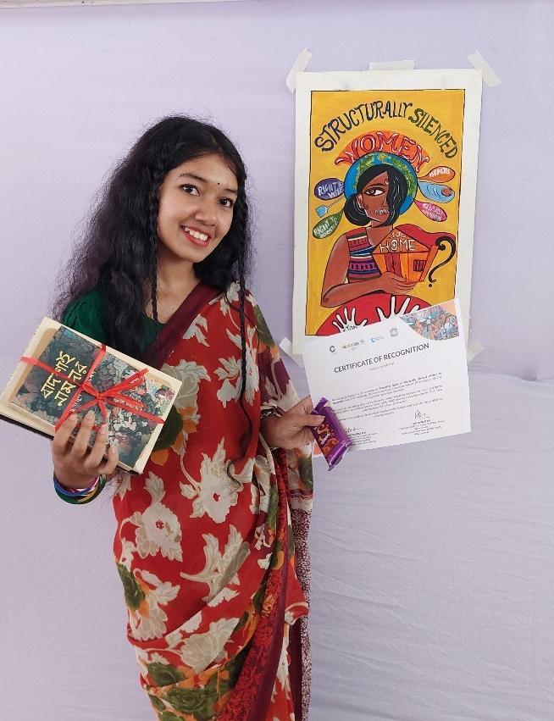

Description of the artwork:
Through the art, Shraboni Sarker voices the struggles of structurally silenced women, stating, "My silence is not a choice; society stitches my right to speak, violates my right to education and health. They label me, restricting my opinions on marriage and education. As an ethnic minority, I lack the right to a safe home and space for my culture. Who am I? A bird in prison!"
Artist’s Short Bio:
Shraboni Sarker is 21 years old and she is a 2nd year student of Fine Arts at Jatia Kabi Kazi Nazrul Islam University. She aims to be an advocate for structurally silenced women and incorporate the voices and struggles of the structurally silenced women in her artwork.

- Artwork:
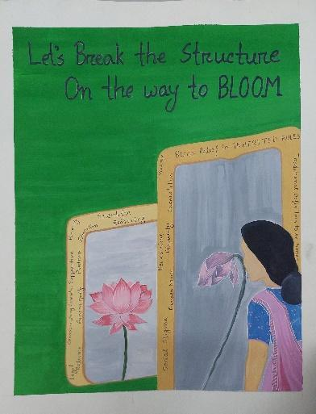 | 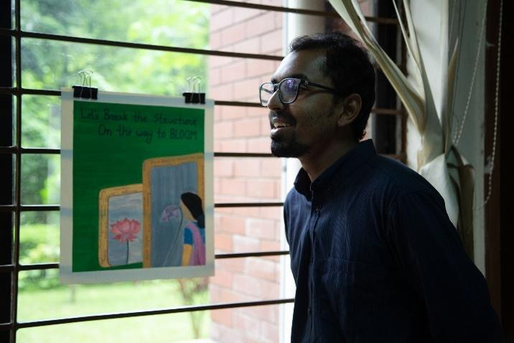

Description of the artwork:
The artwork revolves around societal perspectives, depicting a structurally silenced woman unable to blossom due to prevailing social views. It emphasizes the need for a shift in societal perspectives and a transformation in the social mirror's structure to allow women to bloom. The message resonates with the call to dismantle the structures that inhibit the full realization of women's potential.
Artist’s Short Bio:
Asraf Ullah Rahat is a final year student of the Computer Science & Engineering department at Jahangirnagar University who participated in the workshop on ‘The rights of the structurally silenced women’ and was inspired to develop the artwork to change the societal perspectives for the structurally silenced women.

